Step 1
mkdir -p fruit/apples
cd fruit
mkdir oranges
mkdir pears
cd ..
mkdir -p veggies/leaves/chard
cd veggies/leaves
mkdir lettuce
cd ..
cd veggies
mkdir -p roots/beets
cd roots
mkdir carrots
cd ~
tree
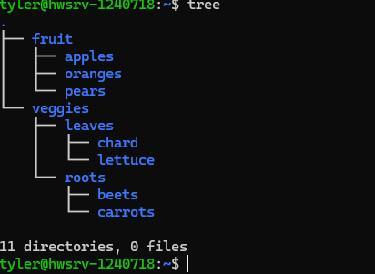

Step 2
cp -r veggies fruit/undecided
tree
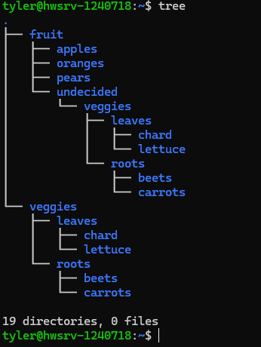
Step 3
mv fruit/undecided/veggies/leaves fruit
tree
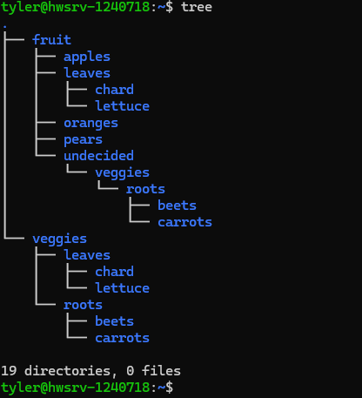
Step 4
rm -r fruit/undecided
rm -r fruit/leaves
tree
Step 5
cd veggies/roots/carrots
man mkdir > mkdir.txt
zip mkdir.txt.zip mkdir.txt
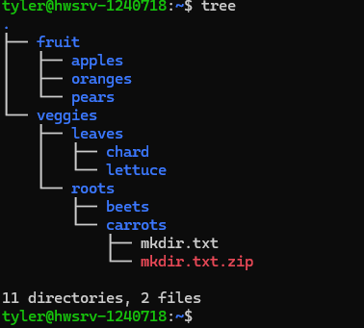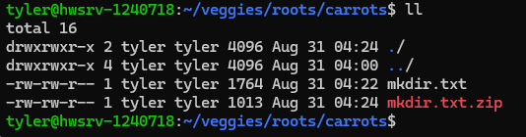
Step 6
chmod g-w mkdir.txt
chmod g-w mkdir.txt.zip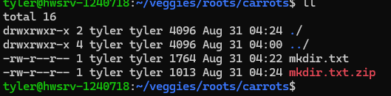
Step 7
unzip -v mkdir.txt.zip
Compression rate was 52%

